
Hip Protector
Implementation
Toolkit

VISN 8 Patient Safety Center of Inquiry
Hip Protector Implementation Toolkit

Table of Contents
Introduction 3

Patient Education Information 4
- Poster from National Falls Toolkit 4
- Video from National Falls Toolkit 4
- Brochure from VISN 8 Falls Clinic 4

Provider Information 5
- Peer Counseling to Encourage Adherence 5
- Prescribing Guidelines for Hip Protectors 5
- Standardized Orders for CPRS 7
- Selection of Brands and Models of Hip Protectors 7
- Sizing 7
- Protocol for Hip Protector Replacement 8
- Template for Policy on Hip Protectors 8
- Laundering Procedure 8
- Stocking Procedure 9
- Hip Protector Fair 9
- Communications 9
- Monitoring Tools 10
- Education for Staff 11

Appendices 12
Appendix A. Hip Protector Order Sets (sample) 12
Appendix B. Falls Policy including Hip Protectors for High-Risk Patients (sample) 13
Appendix C. Hip Protector Poster: National Center for Patient Safety 19
Appendix D. Hip Protector Brochure: Patient 20
Appendix E. Hip Protector Brochure: Provider 23
Appendix F. PowerPoint Presentation for Staff 26

Introduction

External hip protectors are girdle-like devices, with shells made of polyurethane., Multiple types of hip protectors are available on the market and can be divided into soft shell hip protectors that absorb the energy and re-distribute the force of fall, hard shell hip protectors that shunt the energy of the impact into the surrounding soft tissues and hybrid models that combine the hard and soft shell. A workgroup at the Tampa VA Patient Safety Center of Inquiry, in conjunction with national experts and manufacturers, developed toolkit for providers to aid in the implementation of hip protectors. Although the scientific evidence is mixed, some large randomized controlled trials have demonstrated their usefulness in nursing home settings for preventing hip fractures in older adults. The goal of this toolkit is to promote the routine use of hip protectors in nursing homes by providing physicians, nurses, therapists and others with information and tools to assist them and overcome barriers to their use. These guidelines were developed based on feedback received from participating sites in VISN 8 and research we conducted about the barriers and facilitators affecting the use of hip protectors and durability studies in the VISN 8 Patient Safety Center of Inquiry.,

Patient Education Materials

Poster from National Falls Toolkit (see Appendix C)

Video from National Falls Toolkit (available from VA NCPS, Ann Arbor, MI or Patient Safety Manager at your facility)

Brochure from VISN 8 Falls Clinic (see Appendix D)

Provider Information

1. Peer Counseling to Encourage Adherence
Peer support programs are used to improve self management for persons with chronic illnesses such as diabetes, adherence to medications and other medical treatments, and to help people change health behaviors such as physical activity and diet. While no research specifically supports the use of peer support in promoting adherence to wearing hip protectors, it is likely to positively influence patients’ beliefs and attitudes about fall protection and the use of hip protectors and self-efficacy, or the belief a person has that they are capable of performing a given activity. Positive beliefs and attitudes in turn are likely to increase one’s intention to use hip protectors as recommended by health care providers and one’s actual wearing of hip protectors.

Steps in Using Peer Support
- From your care setting or clinical practice, identify individuals who are at risk for hip fractures, who consistently use hip protectors, and who believe that the hip protectors are helping to prevent a fracture. Look for outgoing and persuasive individuals or individuals who appear to be “natural leaders.”
- Ask this individual if he/she would be willing to talk to other veterans who are prescribed hip protectors addressing from his/her point of view:
1) Advantages of wearing hip protectors,
2) Disadvantages of wearing hip protectors, and risks vs. benefits (low harm, potential benefit)
3. Things they learned about wearing hip protectors that might make it easier for someone else.
- Meet with this person and rehearse peer counseling session through role playing, or ask your VAMC patient education program to help with training.
- Consider asking the peer counselor to speak to an individual in your practice who is being prescribed hip protectors for the first time or to an individual who is noncompliant with their use.
- Make sure you get your patient’s permission before you ask the peer counselor to speak to him/her, either in person or via phone call.
- Document in medical record as necessary.

2. Prescribing Guidelines for Hip Protectors
- Prescribing providers (MDs, ARNPs, and PAs, should be actively involved in the hip protector implementation program within the healthcare organization and practice setting. Should a patient decline the use of hip protectors, the prescribing provider should educate the patient on risks for hip fracture and the protective properties of hip protectors, offering the patient choices of brands and products to select from. If the patient still chooses to not wear a hip protector, this decision should be entered into the medical record.

Hip protector prescription should be based on risk for injury (hip fracture), not risk for falls. However, risk for falls is a consideration, but is not the primary indication for a patient’s need for hip protectors. Here is the proposed algorithm:
- (a) age over 70, and
(b) at least two risk factors for osteoporosis (smoking, ETOH abuse, malabsorption, hyperthyroidism, hyperparathyroidism, COPD, prolonged use of steroids, antiepileptics, TZDs, diabetes, hypogonadism or total androgen blockade for metastatic prostate ca, female sex, BMI<21, liver disease, s/p organ transplant, etc.) and
(c) had at least one fall in the prior 12 months; or if no falls, have at least two risk factors for falls (multiple centrally-acting medications such as benzodiazepines, psychotropics, antidepressants, abnormal gait, ADL deficits, impaired vision, peripheral neuropathy, etc.);

OR
- have documented osteoporosis (T score<-2.5) by DEXA scanning; OR
- History of fall-related fracture.
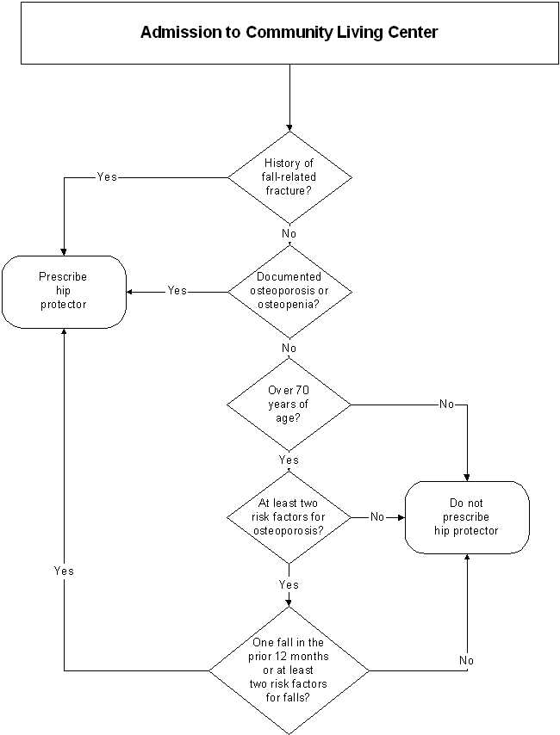

3. Standardized Orders for CPRS
Standardized orders will assist in ordering hip protectors for a specific individual. They may not be applicable for ordering them in bulk for a unit. Standardized orders for CPRS should have following elements (see appendix A with an example of hip protector order set):
- Prosthetic consult
- Brand, model, size (hip circumference)
- Number of pairs
- Duration of wear (daytime, 24 hours, high risk activities only)

4. Selection of Brands and Models of Hip Protectors
Because no national or international standards exist and as minimal risk devices hip protectors do not have FDA oversight, we had no choice but to rely on manufacturers' information. In addition, based on work done at the VISN 8 PSC we would like all manufacturers to demonstrate:
- The efficacy of the hip protector to decrease the energy of impact bellow 3100N (an average force needed to fracture a 75 yr old female hip),
- Durable after repeated washings and dryings or multiple impacts, and
- Testing under ISO certification to ensure quality control.
There are many different brands and models available on the market, including sweatpants and shorts which may be more appealing to some individuals compared to standard hip protectors. Having multiple choices available on your unit to better match patient needs and preferences will ensure better adherence with wear.
When presenting hip protectors to patients, offer multiple versions of undergarments and clothing so that the patient can make selections. This involvement in decision-making, when appropriate, may positively influence adherence.
Utilize the patient/caregiver education videos and brochures in the National Falls Toolkit Media Box, and document patient/caregiver education in the medical record.

5. Sizing
Sizing varies by manufacturer; so after deciding on which hip protector to order, you will need to check the manufacturer’s sizing information. Some products are color coded by size, others are not. Some facilities mark the size on the outside of the garment using a black permanent marker to more easily identify sizes. For example, Posey, HipSaver and SafeHip sizing are shown below.

 |  | Hip Circumference in Inches
 | Size | Posey Hipster | HipSaver | SafeHip
Male | X Small | 33-35 | 28-31 | ---
 | Small | 35-37 | 32-35 | 29-33
 | Medium | 37-41 | 36-39 | 34-36
 | Large | 41-45 | 40-44 | 37-39
 | XL | 45-49 | 45-50 | 40-43
 | XXL | 49-53 | 51-57 | 44-46
Female | X Small | 33-35 | 28-31 | ---
 | Small | 35-37 | 32-35 | 25-29
 | Medium | 37-41 | 36-39 | 30-32
 | Large | 41-45 | 40-44 | 33-34
 | XL | 45-49 | 45-50 | 35-36
 | XXL | 49-53 | 51-57 | 37-39

6. Protocol for Hip Protectors Replacement
In the absence of independent evaluation, we have to rely on manufacturers' guidelines for when to replace hip protectors. For the pads without a guideline from manufacturers we arbitrarily chose 100 launderings as a cut-off for replacement. Each site should determine the intensity of HP use and decide on a time frame for replacements. All new HP should be dated when they are used for the first time. Some facilities have discovered that iron-on labels work better then permanent markers (that wash out after a while). It is probably more feasible and less disruptive to care if a portion is changed over a certain time interval (e.g. 25% every 3 months, or 50% every 6 months, etc.). Also, hip protectors should be inspected before each use for any obvious sign of damage and discarded (e.g. flattened or ruptured shell, stretched-out, poorly fitting surrounding garment, etc.). In the absence of data to determine how many times a hip protector can be fallen on and still retain protective properties, we recommend replacing a hip protectors are after a direct fall onto the pad or shell. While the replacement protocol may be perceived as time and work intensive, it is crucial to ensure that hip protectors are indeed protective when used and that they are taken out of circulation, when appropriate. In the future, manufacturers may be inserting a dye pack on the hip pad or shell that breaks upon impact, so you would know when to discard it.

7. Template for policy on hip protectors
Local teams should review existing fall policy; discuss/refine elements to include, e.g. laundering, stocking, sizing, who orders, risk assessment, selection guidelines, documentation. The goals are to incorporate hip protector content into existing fall policy or develop new policy specific for hip protectors and to obtain concurrence from all services/departments named in policy (see Appendix B for a template of a falls policy including hip protectors).

8. Laundering Procedure (Target Audience: Laundry)
Studies at the VISN 8 Patient Safety Center of Inquiry have found that the protective properties of hip protectors may be reduced with repeated launderings. The most important factor in the reduced protective properties for soft hip protectors was residual moisture found in the pad after laundering. For hard hip protectors, the most important factor in reduced protective properties was the warping of the hard protective outer shell after multiple launderings. In other words, for soft hip protectors, moisture left in the pad reduces its effectiveness in preventing hip fractures. For hard hip protectors, the warping or “flattening out” of the outer shell reduces its effectiveness in preventing hip fractures. For these reasons we recommend that someone in your facility should:
- Review laundering procedures to insure adequate drying of all soft shell hip protectors.
- Whoever is responsible for removing the pads from the dryer should make sure they are dry to the touch. Squeeze the pad, and if they feel moist, return them to the dryer. In addition, if garment is worn, thinned, frayed, or feels unusual (hard lump, sharp edge, etc.) in any way, remove from circulation.
- Examine the outer shell of the hard hip protectors to assure they still are retaining their protective dome shape. If they are not, remove them from circulation.
- The adequate length of a drying cycle to completely dry a hip protector will vary with respect to how hot the dryer is and the specific brand of hip protector. For these reasons, it is difficult to recommend a specific drying time. Attention should be given to allow for enough space for the garments to freely move during drying, otherwise pads may melt.
In the future, manufacturers may place a dye strip in the garment that fades with each washing. When the strip disappears you would know it is time to throw the garment out.

9. Stocking Procedure (Target Audience: Supply)
- Develop process for supplying units with number/sizes needed, and storage on units.
- Develop inventory of best practices: separate bins for different sizes and different products, supplying in nurse servers, adding hip protector to check list for nurse servers

10. Hip Protector Fair (optional)
A hip protector fair is a way to introduce staff to available products, and help them select what would work on their units or for the type of patients they care for. It would be good idea to do it at the beginning of the implementation process and, afterwards on an annual or biannual basis (depending on staff turnover rate). During the development process of this toolkit the VISN 8 PSC staff visited each facility in VISN 8 and displayed different brands and models of HP. Based on the available information from the manufacturers and our laboratory data we selected 3 brands that, at least, somewhat, met our minimum standards (HipSaver, Posey Hipsters and SafeHip) to suit different patient populations. We also provided patient/staff education (15 min PowerPoint presentation and brochures included in the toolkit) at the fairs.

11. Communication (who will wear hip protectors and how will they be stored) (Target Audience: Unit Staff)
Communication about hip protectors is important to insure that people and things do not fall through the cracks. Units that have incorporated hip protector use as part of their standard of care begin educating patients and families about hip protectors on the day of admission, indicating that “for everyone’s safety, our patients wear hip protectors”. Once the brand and version of hip protector is selected by the patient, they will set up a communication system to inform the caregivers, once an order is written by the prescribing provider.

Units that have successfully implemented hip protectors have usually standardized the process for who will wear them and how this information is communicated. It is probably best to use the form of communication that you know already works on your unit. For example, some units add a place to the Kardex that indicates if a hip protector is to be worn. Other units communicate the use of hip protectors through hand off documentation, white boards, or other means. Some units will use all communication systems: List of patients along with hip protector garment (undergarment and / or clothing), and size in the nursing conference room, patient supply server, ADL treatment sheet, and kardex.

The important thing to remember is that the whole care team should know if a person is supposed to wear hip protectors or not. Someone should also be responsible for making sure that the hip protectors are always stored in the same place so that staff can easily find them when they need them. A convenient place, like next to the pajamas or on the linen cart often works well.

12. Monitoring Tools (Target Audience: Nurse Managers with Site Champions)
a. Add to medical orders as a prescribing template.
b. Add to care plans
c. Post fall template check box for hip protector use
d. HP in treatment sheet, or in ADL template
e. Observation, chart review
f. Add to Communication/Hand-off tool for change of shift report
g. Implementation checklist. As you take steps to increase the use of hip protectors at your facility, tracking implementation activities will help you to keep organized and track progress. Use this simple checklist to help you stay on track. Feel free to modify the checklist to suit your specific needs. For example, you may want to track more closely activities across several units or hospital areas.

 | Did you… | Implementation Notes | Date Completed
 | Display the poster in prominent places in the targeted units?
 | Present the video f to targeted staff?
 | Disseminate the brochure?
 | Implement a peer counseling program to encourage adherence?
 | Implement Prescribing Guidelines for Hip Protectors?
 | Implement Standardized Orders for CPRS?
 | Disseminate sizing guidelines?
 | Develop and disseminate a protocol for hip protector replacement?
 | Implement a protocol for hip protector laundering?
 | Implement a protocol for hip protector stocking?
 | Incorporate hip protector use into existing falls prevention policy?
 | Conduct a hip protector fair for staff on all relevant units?
 | Modify communication protocols and tools to accommodate hip protector use?

13. Education for staff and patients/caregiviers

Brochure on HP (see Appendix E)

PowerPoint presentation for staff (see Appendix F)
- Education videos for staff , patients and caregivers in the National Falls Toolkit, Media Box.

APPENDICES

Appendix A
Hip Protector Order Sets (Sample)

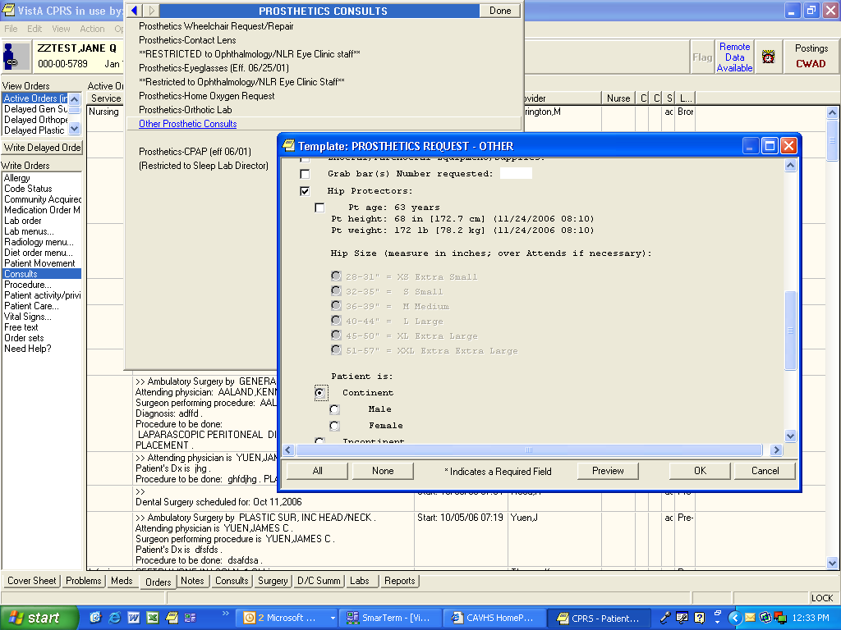
Under Order Set, select Consult, select Prosthetics, select Hip Protectors, Select size and whether patient is continent or not continent.

If either sex is incontinent, they get the nursing home model

Appendix B:
Falls Policy Example including Hip Protectors for High-Risk Patients

Name of facility

Date

CLINICAL MEMORANDUM
NO……………….

FALL PREVENTION PROGRAM

1. PURPOSE: This memorandum is issued to establish guidelines for a comprehensive Fall Prevention Program.

2. SCOPE: The contents of this policy apply to employees who provide acute care and extended care services.

3. POLICY: It is the policy of this medical center that persons receiving inpatient acute care or extended care services have risk for falls assessed and when indicated, implementation of appropriate fall prevention strategies.

a. Fall Definition. The point of accurately capturing all actual and potential occurrences of falls is to identify and communicate patient/resident actual and potential risk factors.

(1) A fall is defined as a sudden, uncontrolled, unintentional, unpurposeful, downward displacement of the body to the floor or ground or potential thereof that would have occurred if not for the patient or caregiver preventing the occurrence. Such actual and potential incidents include all accidental patient falls as well as those resulting from violent blows, seizure, or sudden loss of consciousness.

(2) An episode where a patient/resident lost his/her balance and would have fallen, were it not for staff intervention, is a fall. In other words, an intercepted fall is still a fall for risk assessment purposes.

(3) The presence or absence of a resultant injury is not a factor in the definition of a fall. A fall without injury is still a fall.

(4) When a patient/resident is found on the floor, the event should be investigated to try to determine how they got there, and to put into place an intervention to prevent a reoccurrence. Unless there is evidence suggesting otherwise, the most logical conclusion is that a fall has occurred.

CLINICAL MEMORANDUM NO……………….

(5) The distance to the next lower surface is not a factor in determining whether or not a fall occurred.

b. Procedure.

(1) Assessment: All patients will be assessed using the Morse Fall Risk Tool (MFRT) on admission, transfer, change in status, (for example, change in classification, change in mental status or change in functionality) and after incurring a fall. " Morse Fall Risk Assessment Form" (Appendix A).

(2) Universal Risk: Patients with a MFRT score of 40 or less are considered "Universal Risk” for accidental falls with potential for injury. The staff will implement and utilize the "Universal Fall Precaution Nursing Note" (Appendix B).

(3) Moderate Risk: Patients with a MFRT score 41-80 are considered to be "Moderate Risk" for accidental falls with potential for injury. Staff will implement and utilize the "Moderate Risk Fall Precaution Nursing Note" (Appendix C).

(4) High Risk: Patients with a MFRT score 81 or above are considered "High Risk" for accidental falls with potential for injury. Staff will implement and utilize the "High Risk Fall Precaution Nursing Note" (Appendix D).

c. Post Fall Procedure.

(1) When a fall occurs, the registered nurse (RN) makes a computerized note using the "Post Fall Management Nursing Note" (Appendix E) and will identify the provider as a cosigner. The provider enters a progress note using the "Post Fall Provider Note" (Appendix F) for documenting that the patient who has fallen has been evaluated appropriately for possible injuries related to having fallen.

(2) The RN will reassess the patient using the “Morse Fall Risk Assessment” tool (Appendix A) and will identify the provider as a cosigner.

(3) Completion of the Post Fall Management Nursing Note by the RN and the Post Fall Provider Note by the provider will serve as an incident report in lieu of VA Form 10-2633 “Report of Special Incident Involving a Beneficiary” (Appendix G).

CLINICAL MEMORANDUM NO……………….

(4) The above listed post-fall nursing and provider notes will automatically be sent to the printer located in the Nursing Service Supervisor’s office. The Nursing Supervisor reports all patient falls to the Associate Director for Patient/Nursing Services and the nursing leadership team in the daily morning Nursing Service report. The Associate Director for Patient/Nursing Services reports, as appropriate, significant concerns and patient injuries resulting from accidental falls at the daily hospital Executive Leadership Team meeting.

(5) The Patient Safety Manager, Risk Manager, or designee, reviews all accidental patient falls and assigns a Safety Assessment Code (SAC) score and proceeds with further actions as appropriate in accordance with guidelines described in the VHA National Patient Safety Improvement Handbook (VHA Handbook 1050.1).

(6) Fall incident data is input and maintained in an aggregate database by the Patient Safety Assistant in Quality Management and Improvement Service.

4. ACTION:

a. The Medical Center Director has the overall accountability for the safety of all individuals within the medical center.

b. The Chief of Staff and the Associate Director for Patient/Nursing Services are accountable for implementing fall prevention policies within this facility.

c. The interdisciplinary team is responsible for planning, implementing, and evaluating an appropriate fall prevention treatment plan based on the patient's level of fall risk.

d. The Patient Safety Manager and/or Risk Manager are responsible for the analysis of and reporting of aggregate fall data to the Executive Safety Committee on a quarterly basis.

e. Learning Resources Service, in conjunction with a subject expert identified by the Fall Prevention Program, is responsible for staff education. The Patient Health Education Coordinator is responsible for identifying (if necessary, developing and disseminating) patient health education resources.

5. REFERENCES: Brady, Rebecca; Chester, Frances R.; Pierce, Linda L.; Salter, Judith P.; Schreck, Sharon; and Radziewicz, Rosanne. “Geriatric Falls: Prevention Strategies for the Staff." Journal of Gerontological Nursing. September 1993. pp. 26-32.

CLINICAL MEMORANDUM NO……………….

Brians, Lorraine K.; Alexander, Cristine; Grota, Patti; Chen, Ruth W. H.; Duman, Balarie. “Development of the Risk Tool for Fall Prevention." Rehabilitation Nursing. Vol. 16, No. 2; March/April 1991. pp. 67-69.

Connell, Bettye Rose. “Role of the Environment in Fall Prevention." Clinics in Geriatric Medicine. Vol. 12 (4); November 1996. pp. 859-880.

King, Mary B., and Tinetti, Mary E. “A Multifactorial Approach To Reducing Injurious Falls." Clinics in Geriatric Medicine. Vol. 12 (4). November 1996. pp. 745-757.

James H. Quillen Veteran Affairs Medical Center, Mountain Home, TN. DHCP Computerized Nursing Care Plan for “Potential for Injury."

James H. Quillen Veteran Affairs Medical Center, Mountain Home, TN. Standards of Care / Practice.

VA Pittsburgh Health Care System, Fall Risk Management Program, “Fallingstar." October 1, 2001.

VA Medical Center Washington, DC, Comprehensive Nursing and Rehabilitation Center, “Fall Assessment and Prevention Program." October 2000.

VHA National Center for Patient Safety and VISN 8 Patient Safety Center of Inquiry. “Fall Prevention and Management Flipbook." Version 1.0, January 2001.

6. RESCISSION: Clinical Memorandum
7. RESCISSION DATE:

8. FOLLOW-UP RESPONSIBILITY: Associate Director for Patient/Nursing Services
Chief of Staff

Example of High Risk Fall Precaution Nursing Note (referred to as Appendix D in the above policy):

Guidelines for Morse Fall Score: (instructions only, not visible in text)
MFRT score: 0-40 considered no risk, implement universal precautions
MFRT score: 41-80 considered moderate risk, implement moderate risk precautions
MFRT score: 81 or above considered high risk, implement high risk precautions

Fall Risk Assessment performed at:
admission
transfer
change in condition
post fall

Patient received MRT score of:
0 to 40 (universal fall precautions)
41-80 (moderate risk fall precautions)
81 or above(high risk fall precautions)

Environmental precautions taken:
bed locked and in low position at all times
call bell within easy reach
urinal within easy reach
adequate lighting
room and hall free of clutter and obstacles

Patient precautions:
patient advised to seek assistance during any transfer activity
oriented to surroundings
explained call system with correct pt demonstration
patient encouraged to wear non-skid footwear
patient unable to respond

Patient precautions:
Patient has glasses available within reach
hearing aids are functioning correctly
assistive devices are within reach
understands to have someone present for transfers and ambulation
will be monitored by nursing staff at least Q4H (moderate risk)
will be monitored by nursing staff at least Q2H (high risk).

Discussed with patient/family to:
Sit before standing after bed rest to minimize orthostasis
to avoid stooping, about the effect of medications on mobility and balance
personal safety measures
how to use wheelchairs and lock brakes during transfers in and out of bed
the importance of taking medications as prescribed
to correctly use assistive devices

Discussed with patient/family
The patient will be checked for incontinence or toileted every 2 hrs.
The Nursing staff or family will remain with the patient while transferring, ambulating, toileting and other associated movements.
The patient or family will request assistance prior to transferring, ambulating and toileting.

Provider notified of fall risk score: Yes/No Comment

Provider encouraged to review medications to eliminate unnecessary
prescriptions: Yes
Per policy, hip protectors automatically ordered for HFR patient to wear.
Identify provider as additional signer to note (not visible in note text).
Additional comments:

Appendix C
Hip Protector Poster (from National Falls Toolkit by the VA National Center for Patient Safety)
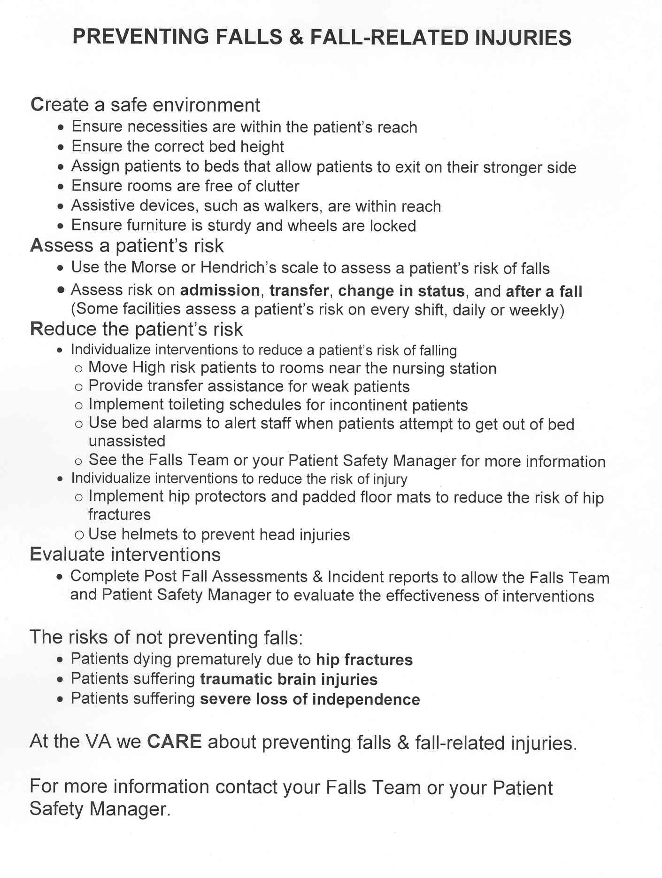
Appendix D
Patient Brochure

Hip
Protectors

Falls Clinic Team Contact:

Type of Hip Protector
Provided/Recommended:

Education Provided
(check all that apply)
Video:
Brochure:
Demonstration:

Education Provided to
(check all that apply)
Patient:
Spouse/Caregiver:
Other:

Suppliers:
The following list is provided for informational purposes only. We do not endorse any particular product over the other, and urge you to discuss which is best with you with your health care provider.

SAFEHIP
(firm shields best for daytime wear)
601 Park East Drive
Woonsocket, RI 02895
Tel: 877-728-3447
Fax: 401-762-8184
www.safehip.com

HIPSAVERS
(soft shields)
7 Hubbard St.
Canton, MA 02021
Tel: 800-358-4477
www.hipsaver.com

HIPSTERS
(soft shields)
J.T. Posey Company
5635 Peck Road
Arcadia, CA 91006-6739
Tel: 800-447-6739
Fax: 800-767-3933
www.posey.com

Will You Look Heavier If You Wear Hip Protectors?
Hip protectors add only 1/2 inch of size over each hip—NOT enough to alter your dress or slack size.

Do Hip Protectors Work?
YES! They do! In recent studies, hip protectors reduced hip fractures by 70% among those who were actually wearing their hip protectors when they suffered a fall. Hip protectors are not designed to prevent spine fractures or pelvic fractures.
Do You Need More Than One Pair of Hip Protectors?
Like any underwear, it is best of have more than one pair. We recommend each client purchase at least three pairs: one pair on, one pair clean and one pair in the wash. There are different styles, including those designed for use with incontinence products. Choose a style you like and will wear. They only work if you wear them!
How Do You Take Care of Your New Hip Protectors?
Care is very easy. Wash and dry on warm permanent press cycles. Avoid hot water and do NOT use bleach on hip protectors to avoid damaging the pads.

Hip Protectors

What is a
Hip Protector?
A hip protector is a special type of undergarment designed to pad your hips in order to reduce the risk of your hip breaking when you fall on your hip.

What Does a
Hip Protector Do?
The hip protector actually has a protective padded shield over each of your hips to provide you with extra protection over the hip. These shields help shunt the force of the fall away from the head of the hip, much like a bicycle helmet prevents head injuries in bicyclists and skaters.
Why Would you Want to Wear Hip Protectors?
Did you know that falls occur in one third of persons over age 65 every year? The most common serious injury that occurs after a fall is a hip fracture.

Hip fractures are expensive. In 1998, fall-related injuries cost $12.6 billion in the United States. The average cost of a hip fracture in 2001 was $33,000.

What Do Hip Protectors Cost?
Costs will vary depending upon the model you choose. Models with harder shields to disperse more force will be slightly more expensive. The range is between $30 and $75 each. When you remember the average cost of a hip fracture, $33,000 plus extensive rehabilitation, the cost of hip protectors is very, very small.

Do Medicare and/or Medicaid Cover the Cost of Hip Protectors?
At this time, neither Medicare nor Medicaid cover hip protectors, but it is hoped that they will be covered very soon. There is a growing trend among private insurance companies to cover hip protectors. If you are going to submit the bill for the hip protectors to your insurance company, you must have your Doctor write a prescription for them.
Where Can You Get Hip Protectors?
Your Doctor can order them from whatever source he/she uses to order walkers and canes. They can also be ordered directly from the supplier. If you are paying for them yourself, you can order them directly from the supplier.
Appendix E.
Provider Brochure

Suppliers:
The following list is provided for informational purposes only. We do not endorse any particular product over the other.

SAFEHIP
(firm shields best for daytime wear)
601 Park East Drive
Woonsocket, RI 02895
Tel: 877-728-3447
Fax: 401-762-8184
www.safehip.com

HIPSAVERS
(soft shields)
7 Hubbard St.
Canton, MA 02021
Tel: 800-358-4477
www.hipsaver.com

HIPSTERS
(soft shields)
J.T. Posey Company
5635 Peck Road
Arcadia, CA 91006-6739
Tel: 800-447-6739
Fax: 800-767-3933
www.posey.com

Hip
Protectors

An Informational Brochure for Healthcare Providers

Hip Protectors

What is a
Hip Protector?
A hip protector is a special type of undergarment designed to pad a hip joint to reduce the risk of hip fracture during a fall.

What Does a Hip Protector Do?
In most cases of hip fracture, the immediate cause of the fracture is a lateral fall with direct impact on the greater trochanter of the proximal femur. Hip protectors are anatomically designed to protect the hip bones during a fall by diminishing the force transferred to the proximal femur by either absorbing or shunting the energy of the impact away from the greater trochanter to the surrounding soft tissues.
Who Should Wear Hip Protectors and Why?
Did you know that falls occur in one third of persons over age 65 every year? The most common serious injury that occurs after a fall is a hip fracture.

Hip fractures are expensive. In 1998, fall-related injuries cost $12.6 billion in the United States. The average cost of a hip fracture in 2001 was $33,000. Individuals most likely to benefit are ones with osteoporosis (or history of multiple risk factors even without hx of fractures) and at increased risk for falls (due to their comorbidities causing sensory or motor deficits, centrally-acting medications affecting balance, etc.)

Do Patients Look Heavier When They Wear Hip Protectors?
Hip protectors add only 1/2 inch of size over each hip—NOT enough to alter the dress or slacks size. Compared to the serious consequences of hip fractures (50% chance of not returning to previous level of functioning, 40% chance of institutionalization, 9-33% mortality in the first year) it should not be a difficult decision for the individual at risk.

Do Hip Protectors Work?
YES! They do! In a large trial, hip protectors reduced hip fractures up to 84% among those who were actually wearing their hip protectors when they suffered a fall. Hip protectors do not have an effect on incidence of spine or pelvic fractures. Adherence with their use is crucial for their effectiveness.

Is One Pair of Hip Protectors Enough?
Like any underwear, it is best of have more than one pair. We recommend each client
Purchase at least three pairs: one pair on, one pair clean and one pair in the wash. There are different styles, including those designed for use with incontinence products. They only work if you wear them!

How Do You Take Care of Hip Protectors?
Care is very easy. Patients should be instructed to wash and dry on warm permanent press cycles, avoid hot water and do NOT use bleach on hip protectors to avoid damaging the pads.

What Do Hip Protectors Cost?
Costs will vary depending upon the model/manufacturer you choose. The range is between $30 and $75 each. For veterans, they are provided free to charge (ordered from the Prosthetics department).

Do Medicare and/or Medicaid Cover the Cost of Hip Protectors?
At this time, neither Medicare nor Medicaid cover hip protectors, but it is hoped that they will be covered very soon. There is a growing trend among private insurance companies to cover hip protectors.
Appendix F
PowerPoint Presentation for Staff

Kannus P, Parkkari J, Niemi S, Pasanen M, Palvannen M, Jarvinen M, Vuori I.Prevention of hip fractures in elderly people with the use of a hip protector. NEJM 2000;343(21): 1506-13.
Rubenstein, L. Hip protectors. A breakthrough in fracture prevention. NEJM 343(21), 1562-1563, 2000.
Holzer G, and Holzer LA. Hip protectors and prevention of hip fracture in older persons. Geriatrics. 2007;62(8):15-20.
Parker MJ, Gillespie WJ, Gillespie LD. Effectiveness of hip protectors for preventing hip fractures in elderly peolpe: systematic review. BMJ 2006;332(7541):571-4.
Sawka AM, Boulos P, Beattie K, Thabane L, Papaioannou A, Gafni A, Cranney A, Zytaruk N, Hanley DA, Adachi JD. Do hip protectors decrease the risk of hip fracture in institutional and community-dwelling elderly? A systematic review and meta-analysis of randomized controlled trails. Osteoporos Int 2005;16:1461-1474.
Bulat, T., Powell-Cope, G., Nelson, A. & Rubenstein, L. (2004). Perceived Barriers and Facilitators for the Use of External Hip Protectors. Journal of Gerotechnology, 3(1), 5-15.
Bulat, T., Applegarth, S. P., Wilkinson, S., Fitzgerald, S., Ahmed, S., & Quigley, P. (2008). Effect of multiple impacts on protective properties of external hip protectors. Clinical Interventions in Aging, 3(3), 567-571.
Bulat, T., Applegarth, S,. Quigley, P,. Shabaz, A,. & Fitzgerald, S. (2009). Durability and residual moisture effects on the mechanical properties of external hip protectors. Gerontechnology, 8(1), 26–34.

