Overview
This section covers the possible interventions for high fall-risk patients.
The main sections are:

I. Environmental Interventions - creating a safe environment for patients
II. Interventions for All Patients - general interventions
III. Individualized Interventions for High Risk Patients - interventions based on specific patient characteristics, such as incontinence, mobility problems, memory disorders (dementia), etc.

Notes on Side Rails
Full side rails should not be used for fall prevention, because they:
- Are considered restraints
- Increase the likelihood of death due to bed entrapment
- Can cause a patient to fall further when climbing over the side rails
- Lead to lost or decreased muscle mass and balance due to immobility

Split side rails are all right as long as the rail by the foot of the bed is
lowered and the rail at the head of the bed is being used as an enabling device.

For more information on alternatives to side rails, see:
Capezuti, E, et al. Interventions to prevent bed-related falls and reduce side rail use. J Gerontol Nurs. 1999:25(11)26-34.

I. Environmental Interventions
There are three key facets of environmental interventions:
A. Environment Set Up/Design
B. Structural Changes

C. Environmental and Equipment Assessments

A. Environment Set Up/Design
The way that furniture and equipment is arranged in the environment is an important aspect of fall prevention.
1. Patient Rooms
The setup of patient’s room should be individualized for that patient. Room set-up for all patients regardless of risk:
a. Patient is assigned to bed that allows the patient to exit towards their stronger side
b. Patient’s bedside table, call bell and light switch are within reach (i.e., patient does not need to lean or stretch in order to obtain items on the bedside table, call a nurse or turn on a light)
c. Room is well lit
d. Room is free of clutter, tripping hazards (such as cords or wires), spills etc.
e. Bathroom and exit doors are clearly marked with both letters and pictures
f. Movable equipment and furniture are locked
g. Furniture is sturdy and comfortable
h. Beds with adjustable height (measured from the top of the mattress to the floor)
Additional features for high fall-risk patients should include:
a. Room located as close as possible to nursing station
b. Non-slip/skid padded floor mat on the exit side of the bed
c. Concave mattress or other method of marking bed boundaries other than side rails³
d. Assistive devices (walking aids, transfer bars, bedside commodes, etc.) located on exit side of bed
e. Night lights to ensure room is illuminated at all times
f. Handrail are accessible and sturdy¹
Both the St. Cloud and Madison VAMCs have developed checklists for high fall-risk room set-ups.
2. Patient Bathrooms
Many falls occur in bathroom and shower areas. The following interventions should be in place in bathrooms.
a. Floor and tub have slip resistant strips or the cleanser used should increase the traction of the floor even when wet.
b. Showers grab bars are installed and covered with a material that increases traction when wet.
c. Toilets should have transfer bars installed at the correct height for the patient
d. Showers have a stool to allow the patient to sit down while showering
3. Hallways
Interventions should be in place to ensure patients and staff are able to move about freely and safely in hallways. Hallways should be:
a. Free of clutter, unused or non-working equipment and tripping hazards, such as electrical cords, and spills
b. Well-lit at all times; lights should be fixed promptly
c. Handrails are accessible and sturdy
d. If possible, provide chairs or other “rest stops” periodically down the hall¹
4. Common Rooms
Common rooms should be set up to promote patient movement while reducing the risk of falling.
a. Rooms are free of clutter, tripping hazards and spills
b. Chairs should be sturdy, comfortable, and easy to get out of¹
c. Handrail should be accessible and sturdy¹
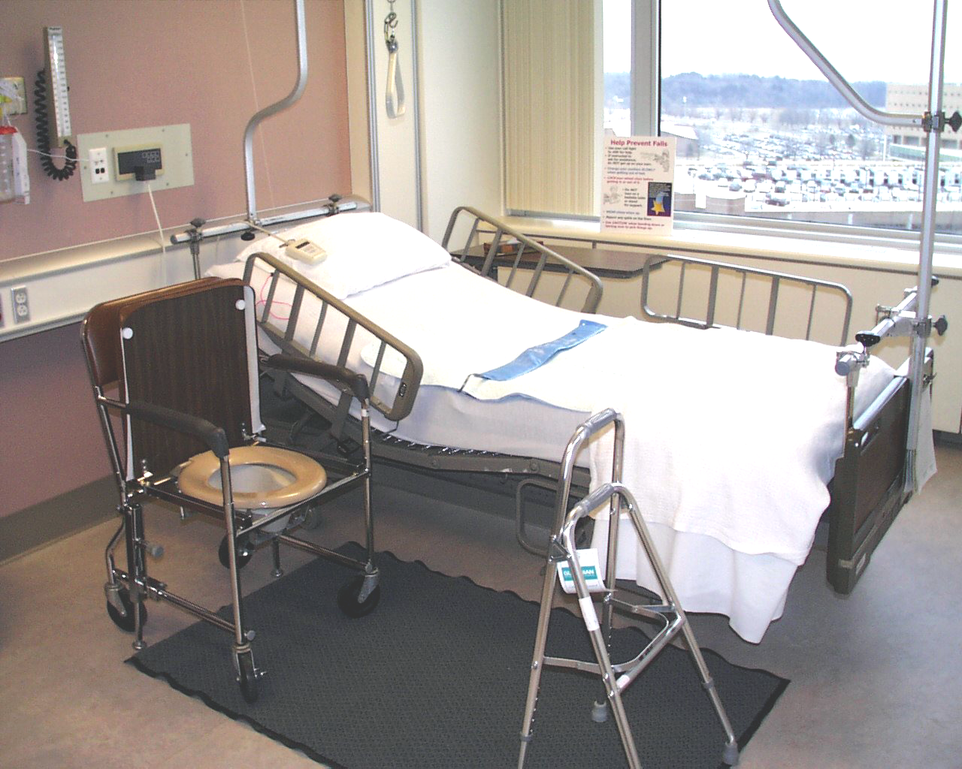
d. “Rest stops” should be spaced periodically opposite the wall so patients walking can take a break¹
Bed trapeze

Falls prevention poster

Non-exit side rails up
for support

Exit side
head rail up for support and foot rail down at all times.

Movable
hand rail (Hemi- walker) always
within reach
Bed controls at fingertips

Bed alarm

Bedside commode placed along- side bed
(replaces urinal)

Non-skid floor

Room illuminated
at all times

Non-slip floor mat absorbs fluids, food, & stool, and prevents slips
e. Rooms should be illuminated at all times

B. Structural Interventions
Structural interventions refer to the physical design of the building or area. These are more expensive than the other interventions, but have more permanent improvements. Some interventions can only be done if remodeling the building; others can be done more easily.
1. Easy Structural Interventions
These structural improvements can be done without major remodeling of the care environment.
a. Installing handrails in hallways, patient rooms and common areas
In patient rooms, hand rails should be installed between the bed and the bathroom¹
b. Installing grab-bars in showers
c. Installing transfer bars next to toilets
d. Locate a high fall-risk patient’s room near the nursing station
2. Moderate Structural Interventions
These structural improvements can be done without major remodeling of the care environment, but are more expensive and require more work.
a. Remove thresholds at doors - ensure that the floor is level everywhere
b. Link bed and tab alarms to the nursing call system, so that alarms can be heard even when a nurse is not at the nursing station
c. Installation of rugs or other flooring to reduce the risk of falls and injuries from falls²
3. Major Structural Interventions
These interventions require major remodeling of the care area.
a. Design a high fall-risk room with more than one bed so that patients can watch each other
b. Install a window in the high fall-risk room to allow patients to be watched without disturbing them, especially at night
c. The high fall-risk room should be right next to the nursing station

C. Environmental and Equipment Assessments
Environmental and equipment assessments are a key way to reduce the hazards in the environment that can increase the risk of falling. They should be done frequently and encompass a wide variety of areas. As stated in the section on interdisciplinary falls teams, responsibilities for environmental assessments can be distributed to staff other than nursing.
1. Facility management and housekeeping staff can ensure:
a. All lights are working properly and areas are well lit (including a night light in the bathroom)
b. Areas are clear of obstacles and clutter, for example, hallways should be clear of equipment not currently being used and the floor of patient rooms should be clear of personal items
c. Handrails are accessible and properly secured to the wall
d. Floors are dry and spills are cleaned up in a timely manner
e. Furniture is sturdy and wheels are locked
f. Furniture is arranged so that patients have space to walk and the grab bars/handrails are accessible
g. Door handles are secure
h. The patient’s bedside table, call bell, water and light switch are within reach (i.e., the patient does not have to lean or get out of bed in order to reach items on the bedside table)
i. Flooring is level and free of tripping hazards such as uneven or broken tiles or thresholds that are above the level of the floor
j. Floors are sealed using a matte polish to reduce glare¹
k. Grab bars are located next to the toilet and in the shower
l. Chairs are comfortable and easy for patients to get into and out of
Note: For patients who are unable to ambulate or transfer safely on their own a triangular pad can be placed to make it more difficult for the patient to get out of the chair on their own. These patients should be watched carefully.

2. Nursing staff ensure:
a. The patient’s bed is in the low position or in a very low position for patients who are too weak to transfer or ambulate by themselves³
b. The patient’s bedside table, water, call bell and light switch are within reach
c. Patient has proper footwear present (i.e., for tiled floors either treaded slipper socks or hard soled shoes)⁴
d. Patient’s clothing does not drag on floor
e. Toilet seat is at a height that allows easy transfer
3. Biotechnologists ensure:
Assistive devices are working properly and repaired in a timely manner (see Equipment Safety Checklist on previous page).
4. Purchasing can ensure:
a. Adjustable height beds are purchased such that the beds can be adjusted to a low position for the patient and high position for staff
b. Furniture purchased is sturdy and capable of being used as a walking aid without slipping out from underneath the patient or falling over on top of the patient
c. Chairs are comfortable to sit in for long periods of time

Conducting Environmental and Equipment Assessments
To aid staff in conducting environmental assessments, some facilities have developed checklists for staff. One such environmental checklist was developed by Bath, N. (see example Falls Policy Attachment F, p. 50).
Janice Morse, in Preventing Patient Falls, provides an equipment checklist. An example modified to include updated technology is on the following page.

Equipment Safety Checklist
Wheelchairs
 | Brakes |  | Secures chair when applied
 | Arm Rest |  | Detaches easily for transfers
 | Leg Rest |  | Adjusts easily
 | Foot Pedals |  | Fold easily so that patient may stand
 | Wheels |  | Are not bent or warped
 | Anti-tip Devices |  | Installed, placed in proper position
Electric Wheelchairs/Scooters
 | Speed |  | Set at lowest setting
 | Horn |  | Works properly
 | Electrical |  | Wires are not exposed
Beds
 | Side Rails |  | Raise and lower easily
 |  |  | Secure when up
 | Wheels |  | Roll/turn easily, do not stick
 | Breaks |  | Secures the bed firmly when applied
 | Mechanics |  | Height adjusts easily (if applicable)
 | Transfer Bars |  | Sturdy, attached properly
 | Over-bed Table |  | Wheels firmly locked
 |  |  | Positioned on wall-side of bed
IV Poles/Stands
 | Pole |  | Raises/lowers easily
 | Wheels |  | Roll easily and turn freely, do not stick
 | Stand |  | Stable, does not tip easily (should be five point base)
Footstools
 | Legs |  | Rubber skid protectors on all feet
 |  |  | Steady – does not rock
 | Top |  | Non-skid surface
Call Bells/Lights
 | Operational |  | Outside door light
 |  |  | Sounds at nursing station
 |  |  | Room number appears on the monitor
 |  |  | Intercom
 |  |  | Room panel signals
 | Accessible |  | Accessible in bathroom
 |  |  | Within reach while patient is in bed
Walkers/Canes
 | Secure |  | Rubber tips in good condition?
 |  |  | Unit is stable
Commode
 | Wheels |  | Roll/turn easily, do not stick
 |  |  | Are weighted and not “top heavy” when a patient is sitting on it
 | Breaks |  | Secure commode when applied
Geri/Broda Chairs
 | Chair | Located on level surface to minimize risk of tipping
 | Wheels | Roll/Turn easily, do not stick
 | Breaks | Applied when chair is stationary
 |  | Secure chair firmly when applied
 | Footplate | Removed when chair is placed in a non-tilt or non-reclined position
 |  | Removed during transfers
 | Positioning | Chair is positioned in proper amount of tilt to prevent sliding or falling forward
 | Tray | Secure

II. Interventions for All Patients
In addition to environmental modifications, there are several interventions that can reduce the likelihood of falls for all patients.
1. While up and moving all patients should wear treaded slipper socks or shoes.⁴
There is an exception to this. If rugs are installed throughout the environment, patients should not wear treaded slipper socks because this could increase their likelihood of falling, especially if they shuffle their feet while walking.
2. Orient the patient to the environment.
Patients who are unfamiliar with their environment are more likely to trip and have difficulty moving around the hospital environment.
3. Approach and transfer patients to their stronger side.
4. Instruct and ensure patients understand how to use assistive devices prior to initiating them.
5. Instruct patients in medication time/dose, side effects and interactions with food or other medications and supplements.

Even if a patient is not considered a high fall-risk, their condition can change, increasing their likelihood of falling. Monitor a patient’s risk factors frequently, upon transfer and whenever his or her status changes. This includes:
1. Evaluating and treating gait changes, postural instability and spasticity
2. Evaluating and treating patients for impaired vision and hearing
3. Evaluating medications for factors that increase the risk of falling (i.e., use of anti-hypotensives, psychotropic medications and drug interactions)
4. Evaluating and treating pain
5. Evaluating and treating orthostatic hypotension
6. Assessing and treating impaired central processing (dementia, delirium, stroke and perception)

III. Individual Interventions for High Fall-Risk Patients

A. All High Fall-Risk Patients
There are certain interventions that should be done for all high fall-risk patients. These include:
1. High fall-risk room set up (see photo, p. 60)
2. Medication review - taking into account risks specific to the patient, such as balance impairment and pain
3. “Falling star” identification program (see CD-ROM for Powerpoint)

B. Fall Frequently
1. Using hip protectors to prevent hip fractures
2. Refer to Rehabilitation Therapy for further evaluation and implementing their recommendations

C. Incontinence/Nocturia
For patients who experience incontinence, nocturia or urgency, there are some things that can be done.
1. Individualized toileting schedule can be initiated
(See CD-ROM for an example toileting schedule)
2. Consider medication for reducing urgency

D. Dizziness/Vertigo
For patients with dizziness or vertigo it is important to monitor and treat orthostatic hypotension. Additionally, patients should be taught to rise slowly from bed to prevent fainting.

E. Fear of Falling
Generally, a fear of falling is the result of some balance or mobility issues. Patients with a fear of falling should have a balance/strength assessment done by a physical or occupational therapist. Additional interventions can include:
1. Using hip protectors — especially if the patient is frail or at high risk of fracture
2. Lowering the bed to a very low position to reduce the distance the patient would fall while getting out of bed

F. Gait/Mobility Problems
For patients who have gait or mobility problems there are several interventions:
1. Have occupational therapy (OT) assess the environment and implement their recommendations
Often OT will recommend aids like transfer bars or raised toilet seats that are based on the individual needs of the patient.
2. Have a physical therapist or occupational therapist assess the patient and implement recommendations
It is important that nursing staff comply with the exercise program because exercise programs have been shown to reduce falls as part of a multifaceted falls prevention program
3. Place a bedside commode next to the bed if the patient has difficulty walking to the bathroom at night
4. Patients who are unable to get out of bed or ambulate on their own should have the bed in a very low position to make it harder for the patient get out of bed without assistance³
5. Patients should be assisted with toileting as needed

If an individual assessment for an exercise program is not feasible, it is good to institute exercise programs that focus on balance.

G. Cognitive/Memory Problems
This includes patients who forget their limitations. For these patients there are a variety of interventions.
1. Bed & Chair Alarms
These alarms can be used to alert the staff when a patient is attempting to transfer on their own. There are two types of alarms:
a. Pressure sensor alarms
When the weight of the patient is removed from the sensor the alarm sounds.
b. Tab alarms
When the patient moves beyond the length of the string attached to them the alarm is sounded
Both of these alarms can be hooked up to the nurse call system and can sound at the nursing station.
2. Bed Placement
The bed can be placed along the wall so that the patient exits towards their stronger side. This eliminates the need for side rails along the side of the bed, reducing the likelihood of bed entrapment.³
3. Hip Protectors
Hip protectors are a good intervention for patients with dementia and other cognitive deficits. They allow the patient to be active while helping to prevent hip fractures if they fall. Generally patients should wear them all the time; however, some patients may find them uncomfortable at night.

4. Frequent Checks on the Patient
The patient should be checked on frequently if in their room. If patient is prone to wandering, a safe place should be provided that is supervised and set up with comfortable chairs and handrails.¹
5. Mobility Aids
When patients with cognitive impairments use mobility aids, several things should be done to ensure the patient knows how and remembers to use the aid.
a. Mobility aids should be placed directly next to the patient’s bed on the side that the patient exits.
b. Patients should use the mobility aid frequently to increase the likelihood that they will remember how to use it.
This will work in the same way that patients with cognitive disorders still know how to tie their shoes.
c. To assess a patient’s knowledge of how to use their mobility aid, ask them to use it, not just explain how to use it.
Even if a patient can’t explain how to use their mobility aid they may be able to use it.⁵

¹ Morse JM. Preventing Patient Falls. Sage Publications, Thousand Oaks, CA 1997.
² Proper flooring a critical measure for preventing slips and falls, Health Hazard Manag Monitor 2003;16(10):1-5
³ Capezuti et al. Individualized interventions to prevent bed-related falls and reduce siderail use.
⁴ Meddaugh DI, Friedenberg DL, Knisley R. “Special Socks for Special People: Falls in Special Care Units.” GeriatrNurs. 1996; 17 (1): 24-26.
⁵ Noelker E. Fall training materials. Louis Stokes VA Medical Center. Brecksville, OH.
⁶ Broda. 1999. Safety Operating Instructions

